**Exercise-2**

* **Step 1: Use the same project made in previous exercise.**
* **Step 2: Open git bash and go to the path of your project.**
* **Step 3: First clone it to a suitable location.**

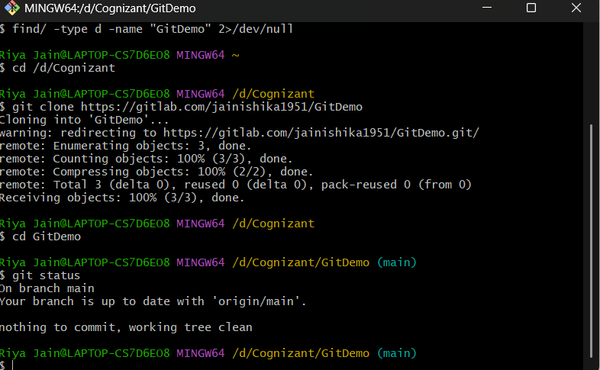

* **Step 4: Create .log file & log folder in GitDemo.**

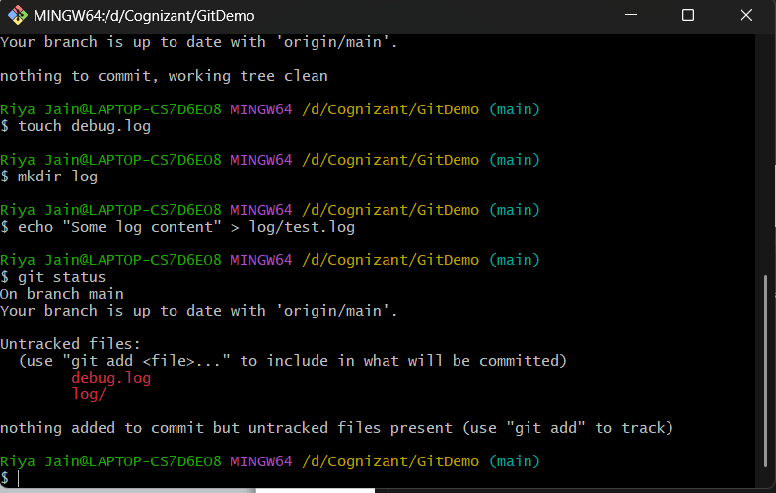

* **Step 5: Check the log and debug in your folder in file explorer.**

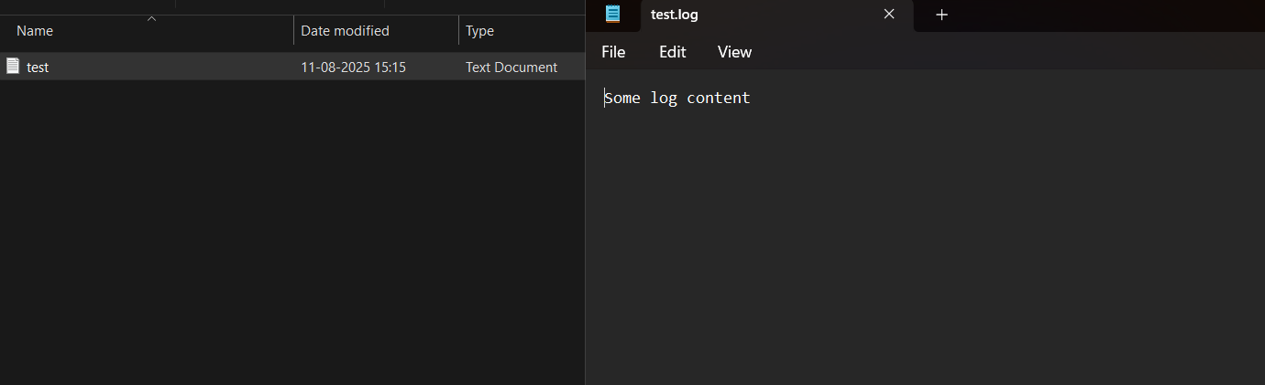

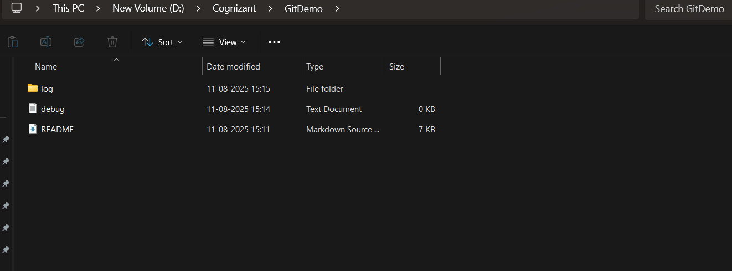

* **Step 6: Edit .gitignore in Notepad++.**

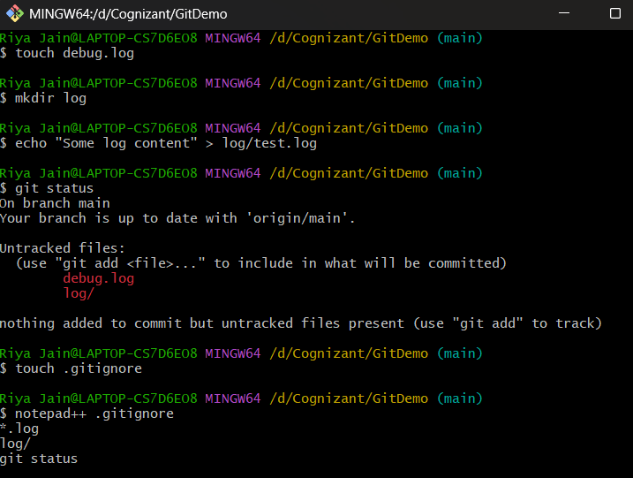

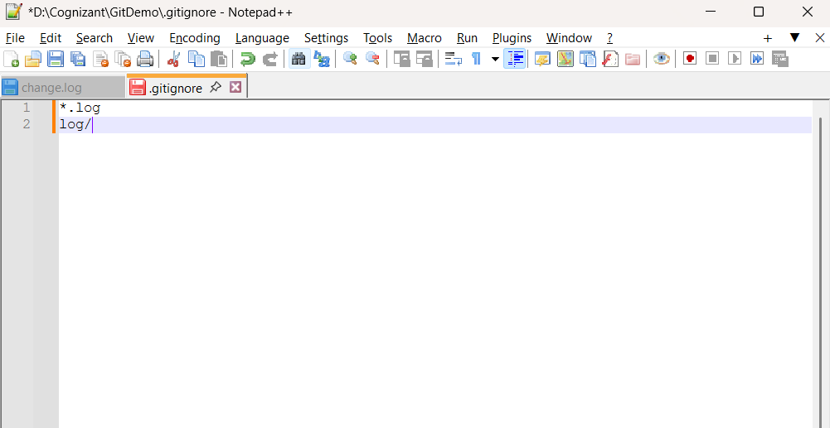

* **Step 7: Status after gitignore:**

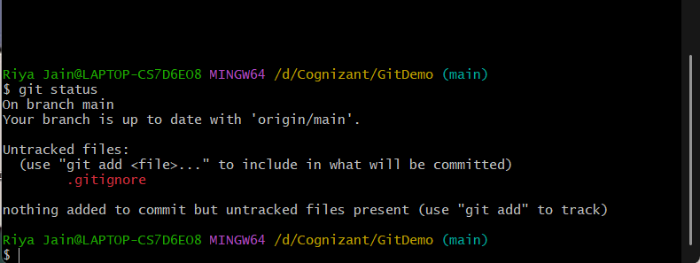

* **Step 8: Commit & push .gitignore**

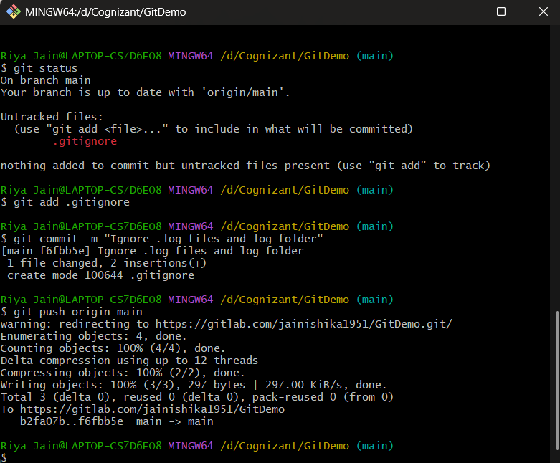

**OUTPUT: Verification through gitlab.**

